Exercise 1: Setting Up Junit
Step 1:Created pom.xml
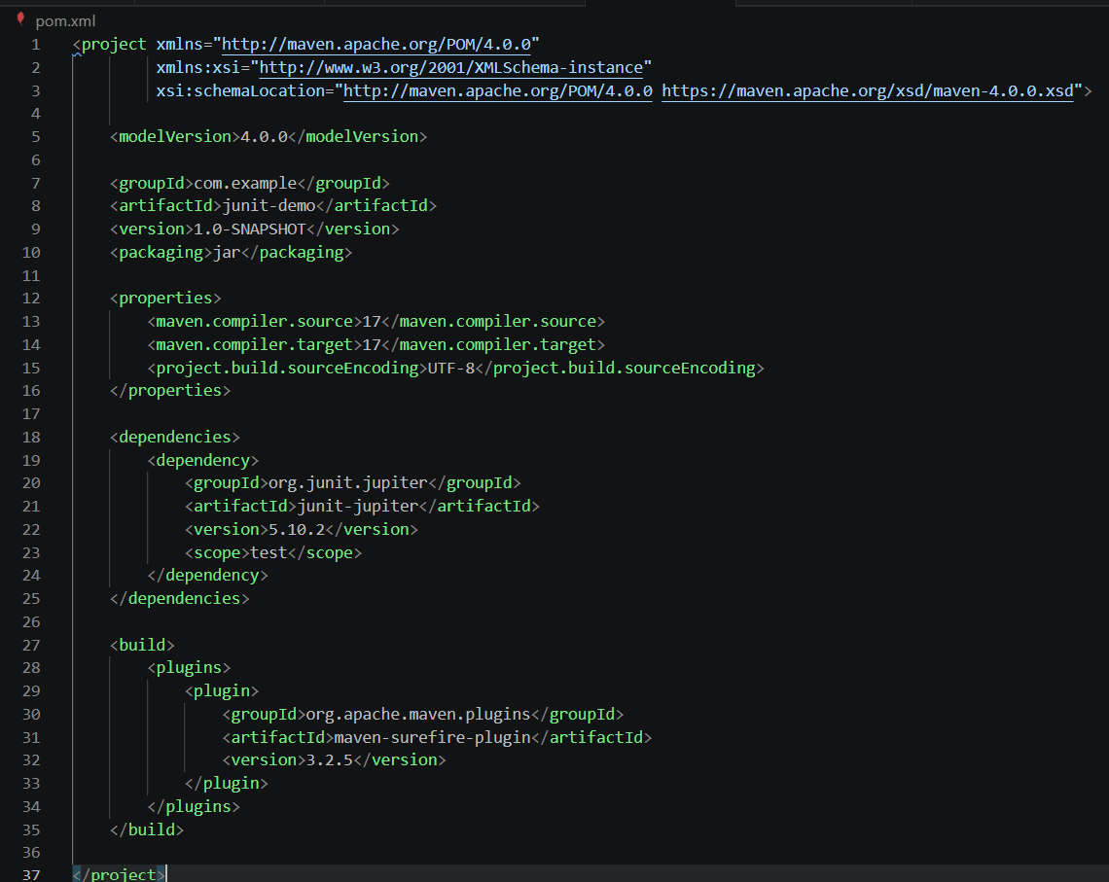
Step 2:Sample testcase Created
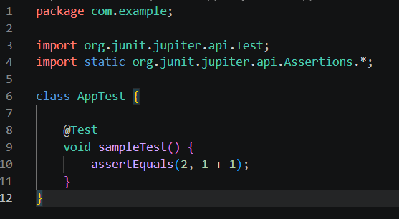

Step 3:Run Command

Step 4:Output
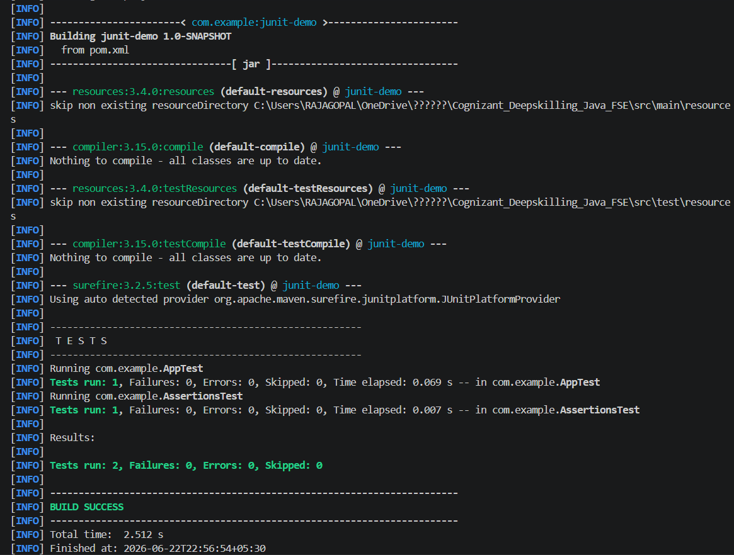
Result:
JUnit was successfully configured and executed.

Exercise 3: Assertions in Junit
Step 1: AssertionsTest.java Created
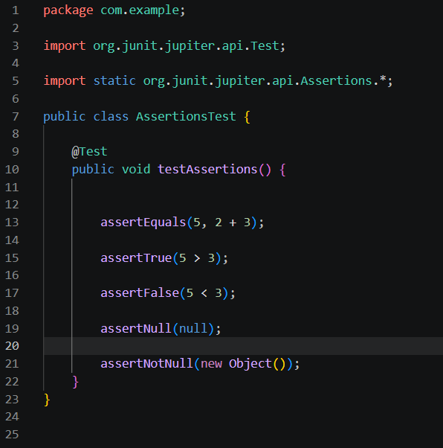

Step 2:Command

Step 3:Output
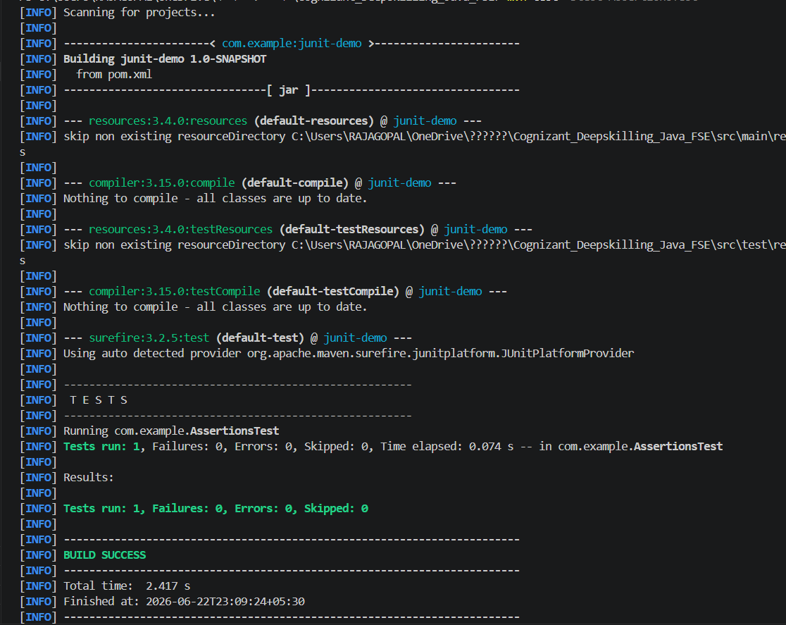

Result:
All JUnit assertions executed successfully.

Exercise 4: Arrange-Act-Assert (AAA) Pattern, Test Fixtures, Setup and Teardown Methods in Junit
Step 1: Create AAATest.java
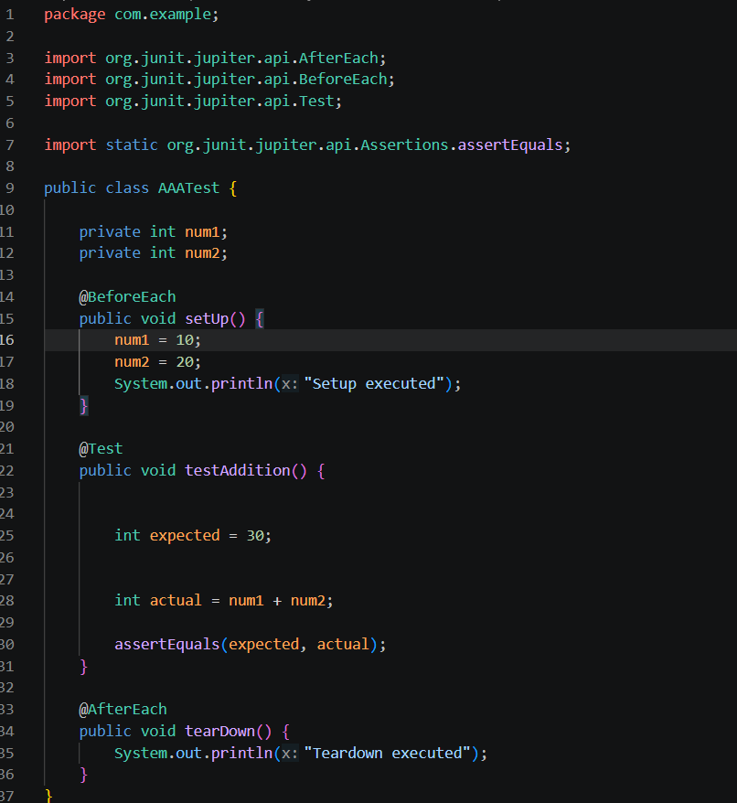
Step 2:Run Command

Step 3:Output
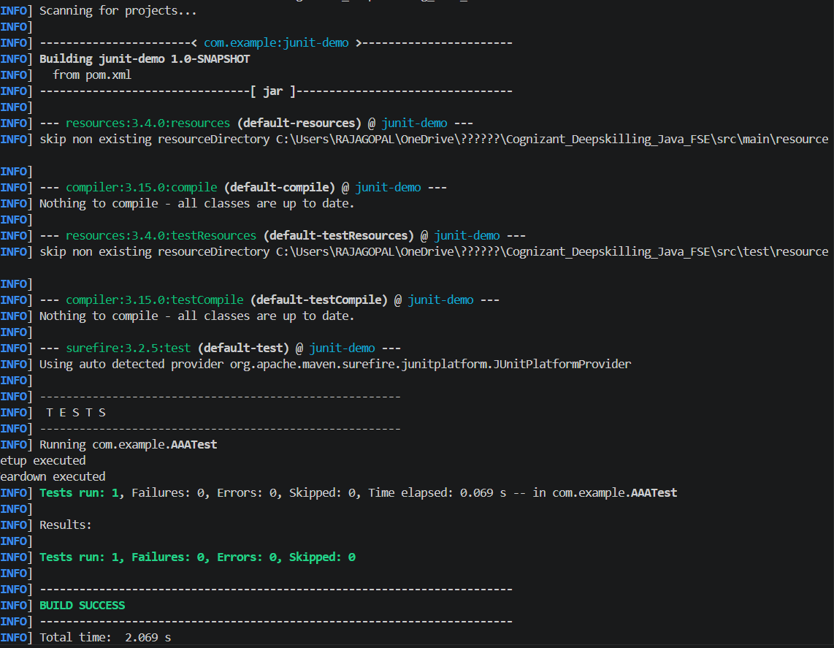

Result:
AAA pattern, setup and teardown methods were implemented successfully.

